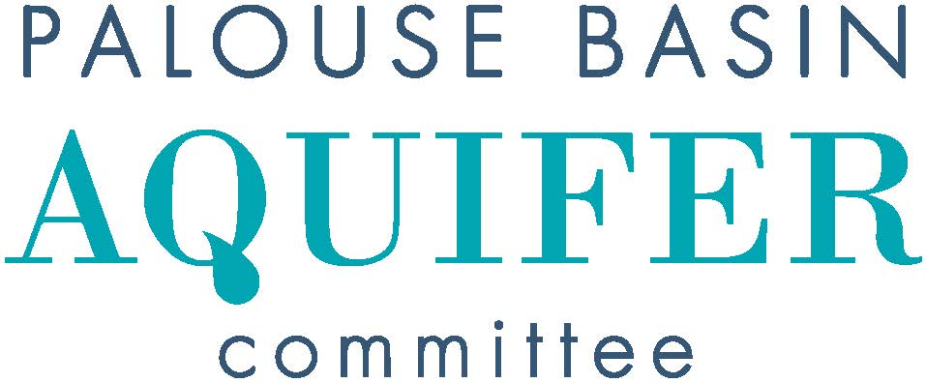
Draft Minutes
Thursday, April 18, 2024, 2:00 PM
UI, FACILITIES SERVICES CENTER, JACK’S CREEK Room 151
https://uidaho.zoom.us/j/89485239499 Passcode PBAC
- Introductions
  - Jeff Lannigan conducted the meeting
X: In-person attendance V: Video attendance
v | Pullman: Cara Haley  City Engineer |  | Moscow: Tyler Palmer (Chair)  Deputy Director, Public Works & Services
 | Pullman: Sean Wells  Public Works Director |  | Moscow: Michael Parker  Water Utility Manager
X | Pullman: Nathan Weller  City Council Member |  | Moscow: Gina Taruscio  City Council Member
 | Whitman County: Mark Storey  Public Works Director/County Engineer |  | Latah County: Paul Kimmell  County Representative
V | Whitman County: Tom Handy  County Commissioner |  | Latah County: Tom Lamar  County Commissioner
X | WSU: Jeff Lannigan (Vice-Chair)  Facilities Services | X | UI: Lana Cohen  Research Associate
 | WSU: Jason Sampson  Asst Director, Environmental Services | X | UI: Rusty Vineyard  Director of Facilities
 | WA, Dept of Ecology: Patrick Cabbage  Unit Supervisor/Hydrogeologist | v | ID, Water Resources: Michelle Richman  Regional Manager/Staff Engineer
v | WA, Dept of Ecology: Chris Beard  Hydrogeologist |  | ID, Water Resources: Daniel Sturgis  Hydrogeologist

Others in attendance: Mike Faupel, Josilyn Watson, Eileen Maccoll, David Hall, Robin Nimmer, Steve Robischon, Colt Shelton, Nicole Fletcher, Nicole (Alta)
- Approval of Minutes
  - March 21, 2024 Meeting Minutes – Motioned Lane, Second Cohen, pass 2:05
- Public Comment for Items not on Agenda
  - Pullman’s Irrigation Schedule will begin June 1
- Unfinished Business
  - Update on IWRB funding – Finance committee scheduled to meet May 13, work session May 23, board meeting May 24
- New Business
- Presentations & Discussion
  - Josilyn presented an update on water conservation outreach
- Subcommittee Reports
  - Interagency Agreement and Bylaws – update on entity MOA agreements
    - Final draft under City of Moscow legal review
  - Budget
    - budget report –
      - Reviewed past month’s finances with Rusty
      - Mike meeting with Lee Espey April 19, will review PBAC finances and plan for oversight during transition
  - Communications – Met April 16
    - Re-engaging stakeholder engagement group
    - Will review and update outreach presentation materials
    - Will review and update external messaging regarding supplemental water supply alternatives
    - Discussed possibility of re-naming water supply alternatives
    - Discussed looking long-term impacts of water conservation from different perspectives – such as how many years of aquifer usage may be gained from conservation practices already implemented
    - PBAC will provide updates to member entities regarding supplemental water supply planning this Summer
    - Discussed reasons for not looking at water usage as a competition between entities, the need for additional collaboration, re-branding PBAC’s overall message, changing the yardstick for messaging conservation – using time instead of gallons
    - This subcommittee will begin meeting monthly
  - Technical – Met earlier in the day
    - Dr. Langman pre-proposal
*Vote – ask Dr. Langman for a formal research proposal – Motioned Langman, seconded by Cohen, passed unanimously 2:25
    - RFP for IWRB funds – will investigate Clearwater River as a supplemental water supply alternative
- Other Reports and Announcements
  - PBAC will be invited to present at the June Pullman Kiwanis meeting
- Next PBAC Meeting:
  - Thursday, May 16 at 2:00 PM
- Adjourn – motioned by Weller, Seconded by Vineyard –

