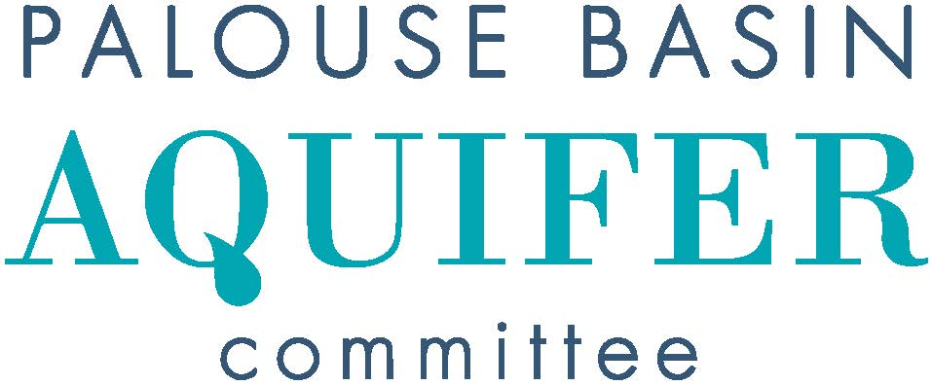
MEETING AGENDA
Thursday, February 15, 2024, 2:00 PM
UI, FACILITIES SERVICES CENTER, JACK’S CREEK Room 151
https://uidaho.zoom.us/j/89485239499 Passcode PBAC
- Introductions
X: In-person attendance V: Video attendance
V | Pullman: Cara Haley  City Engineer | X | Moscow: Tyler Palmer (Chair)  Deputy Director, Public Works & Services
X | Pullman: Sean Wells  Public Works Director |  | Moscow: Michael Parker  Water Utility Manager
X | Pullman: Nathan Weller  City Council Member |  | Moscow: Gina Taruscio  City Council Member
X | Whitman County: Mark Storey  Public Works Director/County Engineer |  | Latah County: Paul Kimmell  County Representative
 | Whitman County: Tom Handy  County Commissioner |  | Latah County: Tom Lamar  County Commissioner
X | WSU: Jeff Lannigan (Vice-Chair)  Facilities Services |  | UI: Lana Cohen  Research Associate
 | WSU: Jason Sampson  Asst Director, Environmental Services | X | UI: Rusty Vineyard  Director of Facilities
V | WA, Dept of Ecology: Patrick Cabbage  Unit Supervisor/Hydrogeologist | X | ID, Water Resources: Michelle Richman  Regional Manager/Staff Engineer
V | WA, Dept of Ecology: Chris Beard  Hydrogeologist |  | ID, Water Resources: Daniel Sturgis  Hydrogeologist

Others in attendance: Mike Faupel, Robin Nimmer, Nicole Fletcher, Eileen MaColl, David Hall, Colt Shelton (v), Steve Robischon(v), Ken Clark (v), Jake Garringer(v)
- Approval of Minutes
  - January 18, 2024 Meeting Minutes approved 2:01 m Vineyard, s Haley
- Public Comment for Items not on Agenda
- Unfinished Business
- New Business
  - Updates on PBAC/WDOE/IDWR meeting
  - PBAC/LOID meeting update
  - Grant opportunity – WDOE drought/water scarcity planning
- Presentations & Discussion
  - Steve Robischon presented data on alternative water supply analyses – he and Tyler will create scope for a QA contract on this
  - Research Colloqium proposal – will update next month
- Subcommittee Reports
  - Interagency Agreement and Bylaws – update on entity MOA agreements
    - Fully executed version distributed February 2, Whitman Co. clerk signature version will be distributed when available
    - New inter-entity agreement committee met February 8 and will meet February 27
  - Budget
    - budget report - Rusty
  - Communications -
  - Technical – Met earlier on January 16
    - Passive aquifer recharge opportunities
    - South Fork Palouse River gage
    - Next steps Alternative 1 data needs
- Other Reports and Announcements
- Next PBAC Meeting:
  - Thursday, March 21 at 2:00 PM
  - Steve will present 2023 pumping results, Josilyn will present on conservation outreach in Latah County
- Adjourn 3:01 m Vineyard, s Storey

