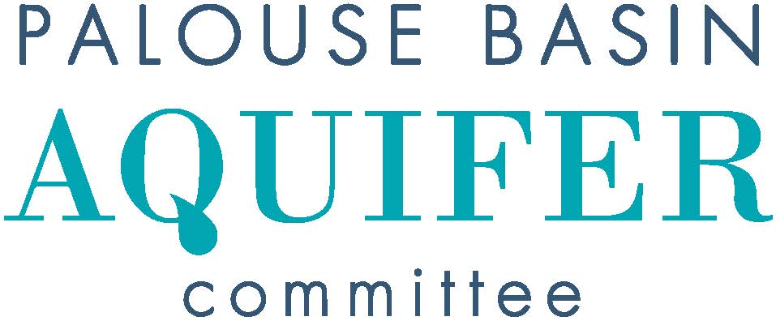
DRAFT MINUTES
Thursday, March 21, 2024, 2:00 PM
UI, FACILITIES SERVICES CENTER, JACK’S CREEK Room 151
https://uidaho.zoom.us/j/89485239499 Passcode PBAC
- Introductions
X: In-person attendance V: Video attendance
v | Pullman: Cara Haley  City Engineer | x | Moscow: Tyler Palmer (Chair)  Deputy Director, Public Works & Services
 | Pullman: Sean Wells  Public Works Director |  | Moscow: Michael Parker  Water Utility Manager
x | Pullman: Nathan Weller  City Council Member |  | Moscow: Gina Taruscio  City Council Member
 | Whitman County: Mark Storey  Public Works Director/County Engineer | x | Latah County: Paul Kimmell  County Representative
 | Whitman County: Tom Handy  County Commissioner | x | Latah County: Tom Lamar  County Commissioner
x | WSU: Jeff Lannigan (Vice-Chair)  Facilities Services | x | UI: Lana Cohen  Research Associate
 | WSU: Jason Sampson  Asst Director, Environmental Services |  | UI: Rusty Vineyard  Director of Facilities
 | WA, Dept of Ecology: Patrick Cabbage  Unit Supervisor/Hydrogeologist | v | ID, Water Resources: Michelle Richman  Regional Manager/Staff Engineer
v | WA, Dept of Ecology: Chris Beard  Hydrogeologist | v | ID, Water Resources: Daniel Sturgis  Hydrogeologist

Others in attendance: Elieen MacColl, Josilyn Watson, Steve Robischon, Robin Nimmer (Alta), Mike Faupel, Nicole Fletcher (Jacobs), David Hall, Colt Shelton (JUB), Ken Clark, Nicole Guthrie (Alta)
- Approval of Minutes from February 15, 2024 meeting
  - Motioned Lannigan, Second Weller, passed 2:03 pm
- Public Comment for Items not on Agenda - none
- Unfinished Business
  - Update on IWRB funding – Tyler provided an update on the IWRB meeting earlier in the day
*vote on Alta proposal for re-evaluation of water supply alternatives – motioned Cohen, seconded Lannigan, passed unanimously 2:16 pm
  - WDOE funding opportunity update – PBAC missed this and will be alert for future similar opportunities
- New Business
  - Follow-ups to PBAC/IDWR meeting
- Presentations & Discussion
  - Steve Robischon presented 2023 pumping results
    - It was demonstrated that Pullman’s irrigation ordinance has been successful in reducing water usage
  - Josilyn Watson presented on her water conservation outreach on behalf of PBAC and AmeriCorps
- Subcommittee Reports
  - Interagency Agreement and Bylaws – update on entity MOA agreements
    - Ad hoc subcommittee is circulating new agreement and some necessary bylaws revisions, Tyler requested any additional comments be submitted by Friday, March 29
  - Budget
    - budget report
      - Rusty not available, he and Mike reviewed earlier in the week
      - Fyi – Rusty is leaving UI effective April 30, his PBAC seat will be replaced by Lee Espey on an interim basis
  - Communications -
  - Technical – Met earlier in the day
    - Jeff Langman proposal – tabled until later April at the earliest
    - South Fork Palouse River gage – not necessary at this time. SR presented an analysis demonstrating a high correlation between SF Palouse River and Paradise turbidity
    - Alta proposal for re-evaluation of water supply alternatives – recommended to approve contract – vote was earlier
    - Alta 2024 well monitoring contract – recommended for approval
*vote – motioned Haley, seconded Kimmel, Passed unanimously 3:12 pm
- Other Reports and Announcements
  - City of Pullman public forum will be held April 16 regarding the city’s water efficiency goals, all interested parties are encouraged to attend
- Next PBAC Meeting:
  - Thursday, April at 2:00 PM
- Adjourn 3:18 pm

